Recurring tasks from my real week
Draft workflow audit:
# | Task | Classification | Rationale
1 | Debugging code (C#, Python, JS) | Collaborate with AI | I know roughly what's wrong but explaining it out loud with AI catches the actual bug faster than staring at it alone
2 | Watching series/movies (downtime) | Just me | This is meant to be a break from screens and problem-solving — bringing AI into leisure time defeats the point of it
3 | Git/GitHub troubleshooting (branch errors, remote issues) | Delegate to AI with review | Fixable with a clear command sequence, but I run and check each command myself before trusting it
4 | Drafting resume content | Collaborate with AI | Wording needs back-and-forth — AI drafts, I push back on anything that oversells my actual role
5 | Deciding what to actually claim about myself (proof statement, LinkedIn bio) | Collaborate with AI | This needs real interrogation, not just generation — AI pressure-tests my instinct, I make the final call
6 | Writing backend code for FlyRank internship (Express.js, endpoints) | Just me | This is the actual work I'm being evaluated on — if AI writes it, I'm not proving I can do the job
7 | Researching/understanding health-related topics | Collaborate with AI | I ask follow-up questions until I actually understand something, not just accept the first answer
8 | Deciding project scope/features before building | Just me | These are my decisions to own — outsourcing judgment calls about my own work defeats the purpose
9 | Writing LinkedIn/outreach posts | Delegate to AI with review | AI drafts tone and structure, I edit specifics and make sure it doesn't sound generic
10 | Formatting/structuring documents (reports, READMEs) | Fully automate | Low-stakes, mechanical, doesn't need my judgment once I've given the content
11 | Picking a color palette/design system for a website | Collaborate with AI | I have taste opinions but need help translating them into concrete hex codes/systems
12 | Reviewing/correcting my own logic in DSA problems | Just me | If I don't struggle through this myself, I don't actually learn it
13 | Prompt engineering / structuring my own AI requests | Collaborate with AI | Learning to ask better questions is itself a skill I'm building, not something to offload
14 | Drafting cold outreach messages to companies | Delegate to AI with review | AI handles the tone/structure, but I decide who to actually send it to and adjust specifics
15 | Tracking deadlines/assignment requirements (like this one) | Just me | This is my responsibility — if I let AI "manage" this I stop being accountable for my own work

AI Fluency: Framework & Foundations
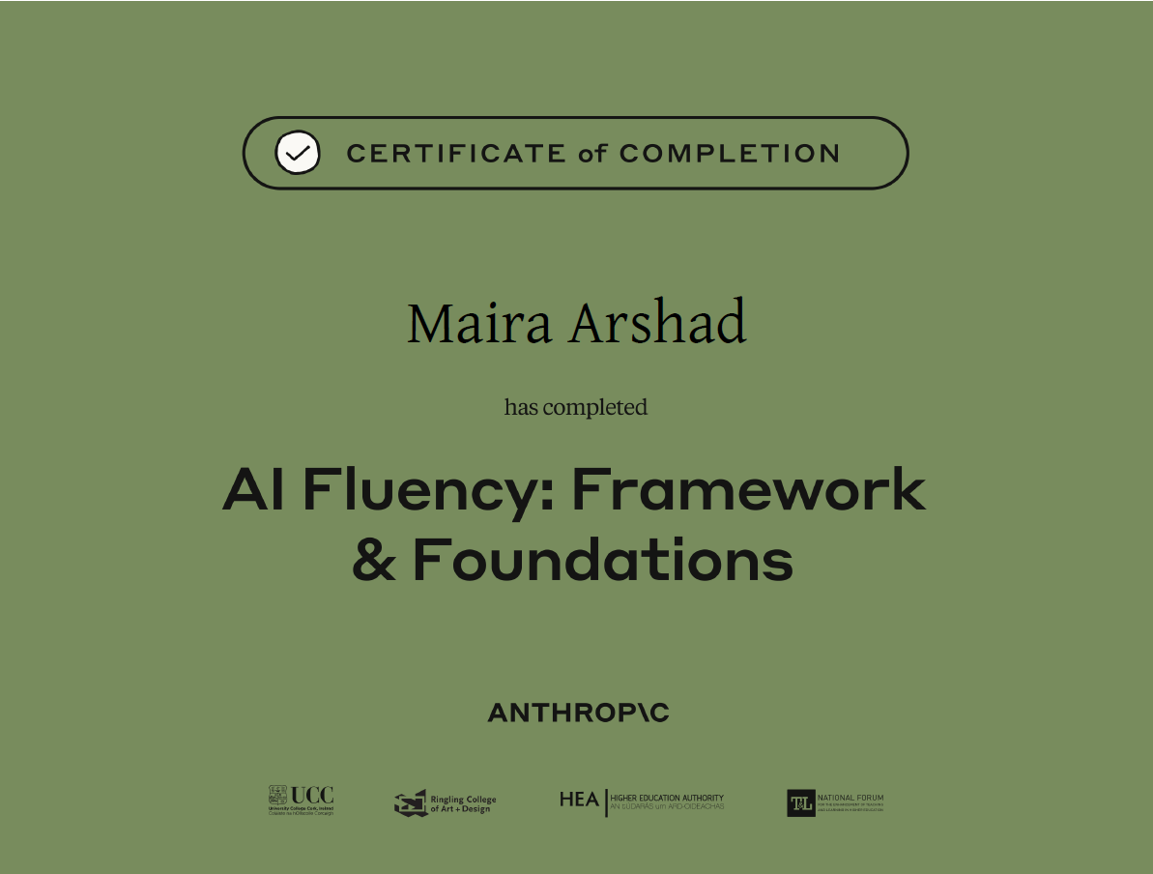

Claude Project evidence
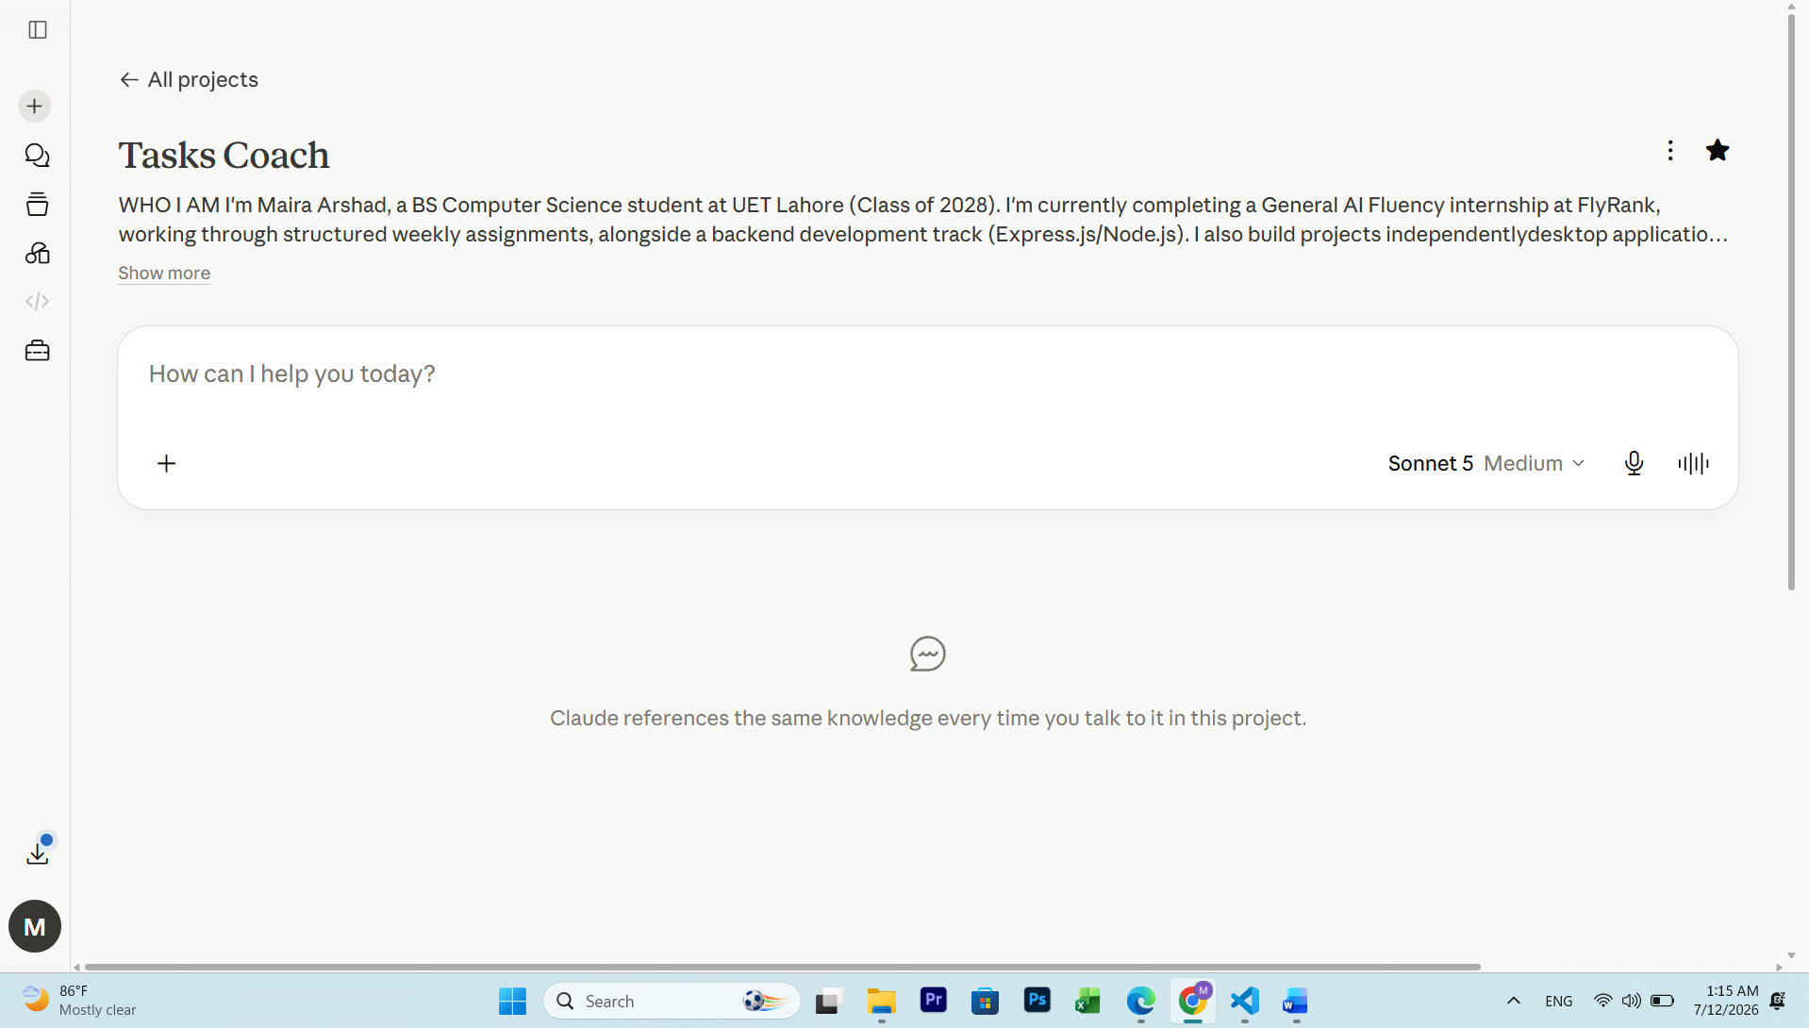

Tasks and what done well means
Writing backend code for FlyRank internship
Code passes all required test cases/endpoints on first review submission, with no more than 1 round of AI-assisted debugging needed before it's submission-ready
Allied Shipping Agency website work
Each section matches the content brief and design system (navy/gold/beige) with no more than 2 revision rounds before it's considered final
Drafting professional content (resume, outreach messages, LinkedIn bios)
Every draft goes through AI pressure-testing before sending, no claim included that I can't defend under a direct follow-up question

